PENNZOIL®
HIGH !MILEAGE VEHICLE®
HIGH MILEAGE
(WITH ACTIVE CLEANSING AGENTS) WHAT YOU DRIVE OR DEAL WITH
- Any high mileage vehicle with over • Worn engine
75,000 miles • Leaking engine and burn-off
WHAT YOU WANT
- A self-cleaning engine • Reduced oil leaks and oil consumption
- A protected engine • An oil specially designed for
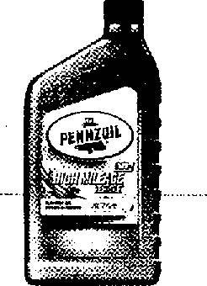

- A responsive engine older vehicles
THE PENNZOIL MOTOR OIL FOR YOU
Cleans out up to 40% of engine sludge in the 1st oil change' +PLUS
Helps reduce leaks and burn-off in worn or high mileage engines,
Cleansing and Protection for High Mileage Engines
* * *
' Based on severe sludge clean-up test using SAE 5W-30
² Engines with 75,000 miles or more

